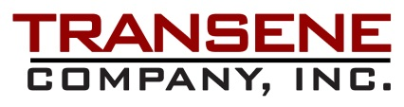

Transene Company has been named an authorized distributor of DisChem SurPass microlithography adhesion promoters/priming agents. The SurPass products in combination with Transene photoresists and etchants to provide complete lithography solutions for the most demanding applications.

SurPass is a waterborne cationic organic surface active agent designed to promote adhesion and improve overall coating quality on a broad range of substrate materials used in microlithography. SurPass promotes adhesion through cationic interaction and modification of the substrate’s surface energy.

ADVANTAGES IN LITHOGRAPHIC PROCESSING:

- Improved resist, polymer, and metal adhesion on a broad range of substrate materials
- Improved patterned resist mold to copper seed layer for subsequent electroforming
- Increased adhesion of evaporated metals to substrate materials
- Improved removal of critical substrate contaminants
- Reduction of EBL exposure energy for minimizing BSE emission, reducing exposure time
- Reduced z-potential for improved coating properties
- May eliminate the need for thermally matched glass
- Replaces pre-wetting solvents
- Eliminates the need for substrate dehydration bake prior to processing
- Non-hazardous waterborne formulation
- No VOC or hazardous breakdown products

SUBSTRATE COMPATIBILITY

SurPass exhibits excellent adhesion properties on a wide range of substrate materials including glass, silicon nitride, metals, metal oxides, ceramics (ruby, sapphire), and plastics such as PET.

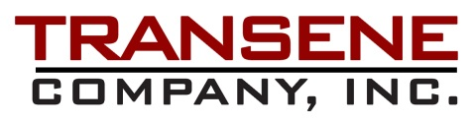

RESIST AND POLYMER COMPATIBILITY
SurPass is compatible with most positive and negative resists and polymer formulations, providing excellent adhesion when used in conjunction with phenolic resin Novolak resist (DNQ/Novolac/ma-N2400/Shipley 1800), polymethyl methacrylate (PMMA), polymethyl glutarimide (PMGI), epoxy based polymers (SU8), polyimide, electron beam resists (including HSQ), chemically and non-chemically amplified photoresist.

ENHANCED COATING PROPERTIES

In addition to promoting adhesion, SurPass modifies the available surface energy to provide a more uniform coating surface for improved resist flow. Evidence suggests that SurPass may be used in polyimide processing both to improve performance and reduce material consumption through reduced zeta potential. SurPass provides improved coating flow and uniformity even where resist/polymer adhesion is not an issue.

SurPass FORMULATION AND PROPERTIES

SurPass is manufactured in two versions—3000 and 4000. Both variants of SurPass are waterborne, non-hazardous, and contain no volatile organic compounds (VOC). The produce no ammonia or other breakdown products during application and are non-corrosive.

SurPass 3000: Aqueous, mildly acidic (pH 2.5-3.5) and contains a cleaning and surfactant package for removal of critical contaminants while optimizing surface energy for improved resist adhesion. May be used as an ultrasonic cleaning solution for combining cleaning with improved adhesion. Water rinse after application may be followed by IPA rinse to minimize dry time.

SurPass 4000: Aqueous, slightly alkaline (pH 9.0-10.0) and contains no additives. Broad range substrate-resist compatibility. Rinse with water or IPA. Excellent for improving adhesion of patterned resist mold on copper seed layer and other substrates for subsequent plating or bonding properties.

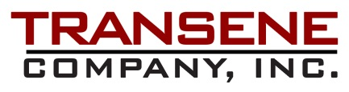

SELECTION OF APPROPRIATE SurPass PRIMER

There are several variables to consider when selecting the SurPass formula best suited to a specific process. These include the type of resist used, the substrate surface material, and post resist exposure requirements. In general, SurPass 3000 is recommended for use with epoxy resists (SU-8) and HSQ e-beam resists while SurPass 4000 is ideal for promoting adhesion of novolac resists (ma-N 1400, ma-N 2400, S-1800, etc.). Initial evaluation of SurPass primers will ideally include comparison of both type 3000 and 4000 to account for process variables that may be further optimized by one formula or the other.

USE AND APPLICATION

SurPass may be applied by spin coating, dip/immersion, spray, or any other means that allows for a coat-rinse-dry cycle followed by application of the resist or other material. SurPass 3000 is especially suited for bulk processing and may be used with ultrasonic agitation to combine final cleaning with adhesion priming. SurPass eliminates the need for a substrate dehydration bake prior to processing.

- Spin coat at 3000 RPM for 30 seconds
- Water rinse (SurPass 3000, SurPass 4000) or IPA rinse (SurPass 4000)
- Dry: Spin dry or dry nitrogen stream

IMMERSION/ULTRASONIC/BATCH PROCESSING

- Clean substrate, normal cycle. Separate wet chemical cleaning can be eliminated when using SurPass 3000 with ultrasonic agitation. No dehydration bake is needed.
- Immerse substrates in SurPass bath for 30-60 seconds.
- DI water rinse.
- Dry via spin or nitrogen stream.

EQUIPMENT REQUIREMENTS

Polypropylene or high density polyethylene recommended.
Filtration: Use of hydrophilic ultra high density polyethylene or equivalent is recommended. Most filters designed for use with DI water are adequate. SurPass is pre-filtered to 0.45 μm.

